Data Science Final Project Abstract  
Bike Sharing System User Number Prediction



r05943011 電子所碩二 沈恩禾, r05943030 電子所碩二 吳思儀

Motivation:

Since the usage demand of bicycles has increased, there are more and more cities are going to introduce the bike sharing system as their public facilities. However, due to the different factor such aspopulation composition (e.g. number of resident, gender, ages … etc) and weather, the number of potential users may be different. In order to reduce the cost and achieve the best benefit, we will need to know information of the number of the potential users to decide the scale of the bike sharing system or charge rates ... etc.

Datasets:

To achieve our goal, we need to collect the corresponding factors information and the users number of bike sharing system as ground truth in the specific city. We decide to use the datasets on Kaggle to get the attributes we need, and check if the analysis results can be applied to predict different bike sharing system user number.

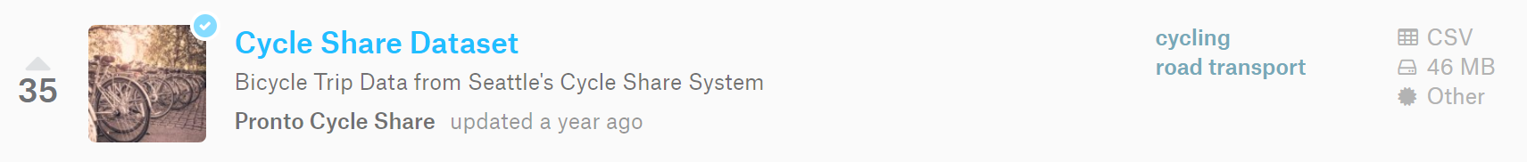

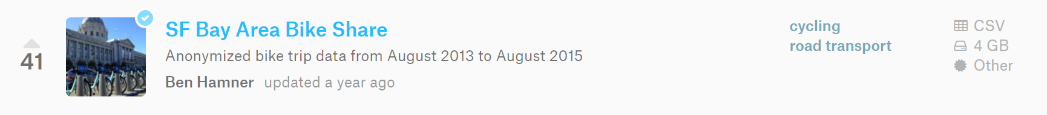

Goal and method:

We wish to predict or generalize certain traits or relations between attributes, and even further extend the hidden knowledge such like: *possible bike sharing popularity*, *population composition to station set up decision* **across** different datasets. *Sklearn* library for simple classification and *Tensorflow, Keras* etc. for complex NN model will be used.

